rpm -ivh https://dl.fedoraproject.org/pub/epel/epel-release-latest-7.noarch.rpm

yum install terminator

How to use Terminator

Run the “terminator” command in the terminal to use it. Once, you fire the command you will see a screen similar to below.

[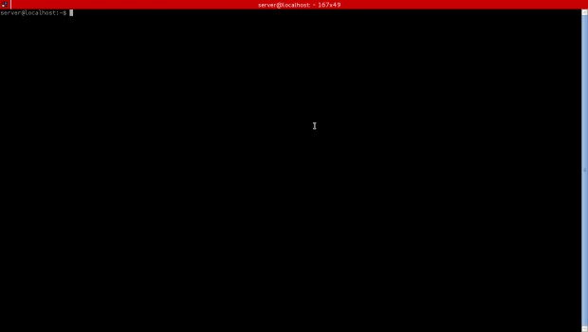](http://www.tecmint.com/wp-content/uploads/2014/01/11.jpeg)

*Terminator Terminal Window*

Terminal Emulator Keyboard Shortcuts

To get the most out of Terminator it is crucial to know the key-bindings to control Terminator. The default shortcut keys that I use most are shown below.

1. Split Terminal Horizontally – Ctrl+Shift+0

[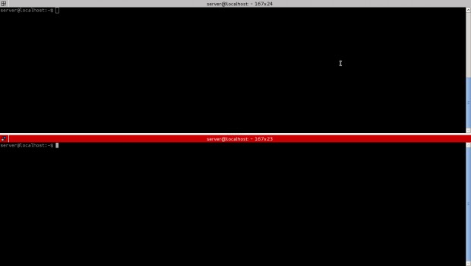](http://www.tecmint.com/wp-content/uploads/2014/01/21.jpeg)

*Split Terminal Windows*

1. Split Terminal Vertically – Ctrl+Shift+E

[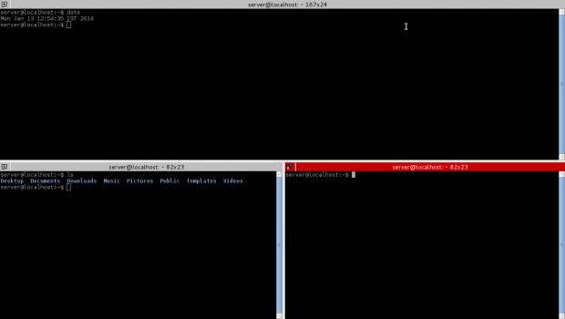](http://www.tecmint.com/wp-content/uploads/2014/01/31.jpeg)

*Split Terminal Vertically*

1. Move Parent Dragbar Right – Ctrl+Shift+Right_Arrow_key
2. Move Parent Dragbar Left – Ctrl+Shift+Left_Arrow_key
3. Move Parent Dragbar Up – Ctrl+Shift+Up_Arrow_key
4. Move Parent Dragbar Down – Ctrl+Shift+Down_Arrow_key
5. Hide/Show Scrollbar – Ctrl+Shift+s

[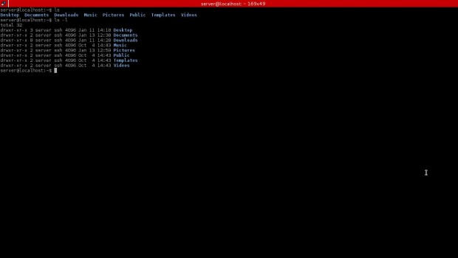](http://www.tecmint.com/wp-content/uploads/2014/01/42.jpeg)

*Hide/Show Terminal Scrollbar*

Note: Check the hidden scrollbar above, it can again be made visible using the same above key combination.

1. Search for a Keyword – Ctrl+Shift+f
2. Move to Next Terminal – Ctrl+Shift+N or Ctrl+Tab

[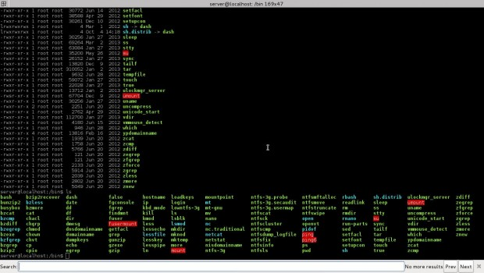](http://www.tecmint.com/wp-content/uploads/2014/01/5.jpeg)

*Move to Next Terminal*

1. Move to the Above Terminal – Alt+Up_Arrow_Key
2. Move to the Below Terminal – Alt+Down_Arrow_Key
3. Move to the Left Terminal – Alt+Left_Arrow_Key
4. Move to the Right Terminal – Alt+Right_Arrow_Key
5. Copy a text to clipboard – Ctrl+Shift+c
6. Paste a text from Clipboard – Ctrl+Shift+v
7. Close the Current Terminal – Ctrl+Shift+w
8. Quit the Terminator – Ctrl+Shift+q
9. Toggle Between Terminals – Ctrl+Shift+x
10. Open New Tab – Ctrl+Shift+t
11. Move to Next Tab – Ctrl+page_Down
12. Move to Previous Tab – Ctrl+Page_up
13. Increase Font size – Ctrl+(+)
14. Decrease Font Size – Ctrl+(­)
15. Reset Font Size to Original – Ctrl+0
16. Toggle Full Screen Mode – F11
17. Reset Terminal – Ctrl+Shift+R
18. Reset Terminal and Clear Window – Ctrl+Shift+G
19. Remove all the terminal grouping – Super+Shift+t
20. Group all Terminal into one – Super+g

Note: Super is a key with the windows logo right of left CTRL.

Reference Links

<https://launchpad.net/terminator>